**Resilience of a delisted threatened species:**

**36-year population trends of Colorado butterfly plant**

**(*Oenothera* *coloradensis;* Onagraceae) on**

**F. E. Warren Air Force Base, Laramie County, Wyoming**

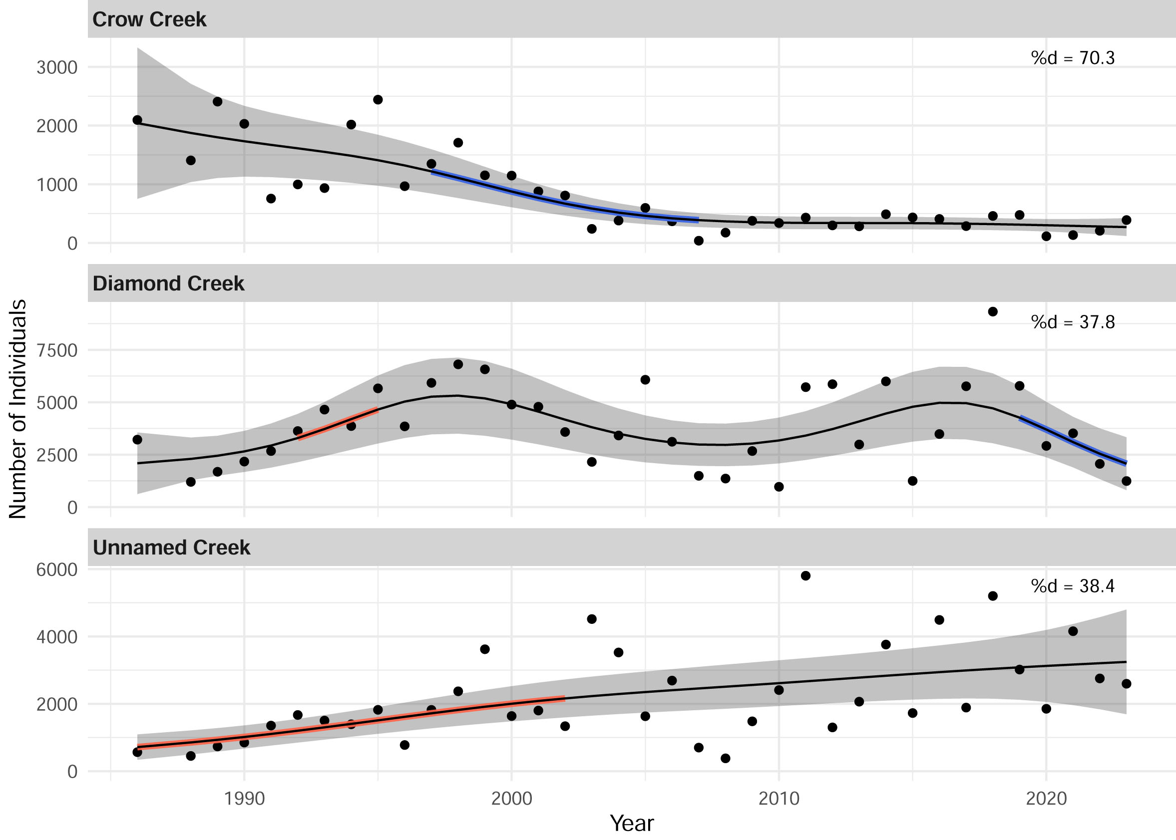

Prepared for:

U.S. Fish and Wildlife Service

300 Vesle Drive

F. E. Warren Air Force Base, Wyoming 82005

By Bonnie Heidel¹, Dorothy Tuthill² and Alice Stears³

Wyoming Natural Diversity Database

University of Wyoming

Laramie, WY 82071

4 March 2024

Agreement No. F19AC00730

¹Wyoming Natural Diversity Database

²Biodiversity Institute, ret.

³Botany Department

### ABSTRACT

Annual census of reproductive Colorado butterfly plants (*Oenothera coloradensis* (Rydberg) W.L. Wagner & Hoch) was initiated in 1986 and conducted consecutively for 36 years from 1988-2023 on F. E. Warren Air Force Base (WAFB), Laramie County, Wyoming. The large WAFB population occupies three creeks with fundamentally different hydrology. This population is the only one on federal land, the only one with habitat in idle condition, and it has the longest-running monitoring program. Thirty six years of census results show significant growth in two creek subpopulations and decrease in the third creek subpopulation. They also demonstrate significantly different patterns of change in subpopulation size between creeks and over time. Not only were patterns of population change different across creeks, but these patterns at the creek level also were often different or even opposed to patterns at the scale of the entire WAFB population. These results support the necessity of comprehensive Post-Delisting Monitoring (PDM) for this species, since the outcome of monitoring at a single creek or short time interval is likely to be an inadequate representation of trends in the broader population. The meteorological conditions over this 36-year period have generally remained favorable and steady for key life history stages of germination and bolting, but increasingly unfavorable for establishment and survival of vegetative plants, with mortality driving trends on Crow Creek where there are declining numbers. We conclude that the 3 creek subpopulations on the WAFB facilitate resilience in the entire population, perhaps by providing spatial redundancy that buffers adverse impacts at smaller scales. Significant trends were not detected as trend-breaks until 5-8 years after their start. We did not analyze the Mann-Kendall test against the model comparison algorithm output, but this raises a question whether five years is adequate to determine population trends. The most surprising result of 2023 monitoring of *O. coloradensis* was discovery of Ute ladies’-tresses (*Spiranthes diluvialis*) in overlapping habitat, treated in a new report section and addressed in a proposed monitoring framework as complementing but separate from COBP monitoring.

Citation for this report: Heidel, B., D. Tuthill and A. Stears. 2023. Resilience of a delisted threatened species: 36-year population trends of Colorado butterfly plant (*Oenothera coloradensis*; Onagraceae) on F. E. Warren Air Force Base, Laramie County, Wyoming. Prepared for U.S. Fish and Wildlife Service and F. E. Warren Air Force Base by the Wyoming Natural Diversity Database (University of Wyoming), Laramie, WY.

On the cover: Trends in Colorado butterfly plant (*Oenothera coloradensis*) creek subpopulations at F.E. Warren Air Force Base, Wyoming, 1988–2023 using generalized additive models.

Table of Contents

INTRODUCTION 1

Overview 1

Life history 1

Population biology 1

STUDY AREA 2

Location 2

Climate 3

METHODS 5

Field census 5

Data analysis – detecting trends 6

Data analysis – detecting changes to trends 6

RESULTS 6

Trends 7

Changes to trends 9

Drawing conclusions 11

Ute ladies’-tresses documentation 12

DISCUSSION 12

2024 Monitoring plans 14

ACKNOWLEDGEMENTS 14

LITERATURE CITED 15

TABLES AND FIGURES

Table 1. Summary statistics for generalized additive models of trends in populations of Colorado butterfly plant (*Oenothera coloradensis*) at F.E. Warren Air Force Base, Wyoming, 1989-2023

Figure 1. Distribution of Colorado butterfly plant (*Oenothera coloradensis*) habitat on F. E. Warren Air Force Base

Figure 2. Precipitation totals and temperature averages in Cheyenne, WY (1984-2023)

Figure 3. Crow Creek annual stream flow (1993-2018).

Figure 4. Trends in Colorado butterfly plant (*Oenothera coloradensis*) overall population numbers at F. E. Warren Air Force Base, by decade and by creek, Cheyenne, Wyoming, 1988-2023

Figure 5. Growth rate (log(lambda) of Colorado butterfly plant (*Oenothera coloradensis*) overall population and creek-level subpopulations at F. E. Warren Air Force Base (1988-2023).

Figure 6. Trend in the population of Colorado butterfly plant (*Oenothera coloradensis*) at F. E. Warren Air Force Base, Wyoming, 1988-2023 and on the three creek subpopulations, using generalized additive model

Figure 7. Breakpoints in the total population size of flowering Colorado butterfly plant (*Oenothera coloradensis*) individuals at F. E. Warren Air Force Base, Cheyenne, Wyoming, 1988-2023 and on the three creek subpopulations, using a model comparison algorithm

Figure 8. Growth rate (log(lambda)) of Colorado butterfly plant (*Oenothera coloradensis*) overall population and creek-level subpopulations at F. E. Warren Air Force Base (1988-2023).

APPENDIX

Appendix A. Colorado butterfly plant(*Oenothera coloradensis*)census numbers on F. E. Warren Air Force Base (1986, 1988-2023)

Appendix B. Colorado butterfly plant (*Oenothera coloradensis*) census results on F. E. Warren Air Force Base riparian subunits (1986, 1988-2023)

Appendix C. Colorado butterfly plant (*Oenothera coloradensis*) census by polygon - raw data on F. E. Warren Air Force Base (recent years; 2016-2023)

Appendix D. Record of *Spiranthes diluvialis* discovery on F. E. Warren Air Force Base

# INTRODUCTION

## Overview

Colorado butterfly plant (*Oenothera coloradensis* (Rydberg) W.L. Wagner & Hoch; syn. *Gaura neomexicana* Woot. ssp. *coloradensis* (Rydb.) Raven & Gregory) is a regional endemic of the North and South Platte River watersheds on the high plains of northeastern Colorado, western Nebraska and southeastern Wyoming. It was listed as Threatened under the Endangered Species Act in 2000 (USFWS 2000). It was delisted in 2019 due to monitoring data that provided evidence of resiliency and discovery of additional populations since its listing (USFWS 2019).

The Colorado butterfly plant (COBP) population on F. E. Warren Air Force Base (WAFB) is one of the three largest known populations, the only one on federal land, and the only that does not have grazing or haying use. It has the longest monitoring record, initiated in 1986 and repeated annually from 1988-2023[1], before, during and after federal designation. Occupied COBP habitat on WAFB encapsulates the range of stream orders occupied by the species throughout its range including perennial, seasonal and ephemeral stream orders.

A COBP Post-Delisting-Monitoring plan (PDM; USFWS 2017) was established before this species was de-listed. The plan called for monitoring population size for at least five years in a sample of populations spanning the species’ distribution, and comparing the range, mean and median of population counts to compiled data to assess recovery against a benchmark. This report represents 2023 monitoring at WAFB as the fourth year of monitoring at a PDM site.

## Life history

COBP was first reported to be a biennial (Raven and Gregory 1972), but demographic monitoring suggests that it is a short-lived perennial (Floyd 1995a, Floyd and Ranker 1998, Stears 2022). COBP reproduces strictly by seed, growing into vegetative plants as rosettes of flat leaves appressed to the ground, in later years sending up a flowering stalk. The species flowers once and dies (referred to as semelparous; also called monocarpic). Germination and bolting both start in the first half of the growing season.

## Population biology

COBP on WAFB can be found along three creek drainages—Crow Creek and its two tributaries (Diamond and Unnamed Creeks)—and have been variously referred to as representing one, two, or three populations. We refer to one, base-wide population comprised of three subpopulations because the species’ distribution is confluent on two creeks, was likely to have been confluent on the third creek prior to Base construction, and the creeks are within 1.5 km of one another. There is high likelihood of genetic exchange via lepidopteran pollination vectors traveling between creeks. This is supported by genetic analysis to date that include Inter-simple Sequence Repeat (Brown 1999, 2000; Tuthill and Brown 2003) and earlier gel electrophoresis (Floyd 1995a).

# STUDY AREA

## Location

The study area is located on WAFB immediately west of Cheyenne (41° 07’N 104° 52’W) in Laramie County, Wyoming. COBPoccupies riparian habitat along Crow Creek, Diamond Creek, and an unnamed, ephemeral creek (hereafter referred to as Unnamed Creek) (Figure 1). Occupied riparian corridor habitat on the creeks span approximately 5.1 km (3.2 miles). COBP distribution is discontinuous on the creeks and the cumulative occupied habitat is about 5 ha (12.4 ac). The creeks are low-gradient drainages in open high plains at 1862-1887 m (6110-6190 ft) elevation with a relief of about 5.7 m per km (ca 30 ft per mile). Most occupied habitat is undeveloped and relatively undisturbed on WAFB.



### Hydrology and Habitat

Occupied habitat lies in broad, gentle valleys. Crow Creek is the largest of the three creeks occupied by COBP plant on WAFB. It has perennial flow, a large watershed, and impoundments that include the municipal water source for Cheyenne, which is also used for irrigation. Diamond Creek and Unnamed Creek are its tributaries. Though climate is uniform across WAFB, hydrology differs between creeks, as do soils and vegetation.

Figure 1. Distribution of Colorado butterfly plant (*Oenothera coloradensis*) habitat on F. E. Warren Air Force Base

Crow Creek habitat is open woodland and wet meadows bordering a wetland thicket dominated by *Salix exigua* (coyote willow). Diamond Creek habitat is in extensive wet meadow along the meandered creek that lies below a relatively steep, north-facing valley slope, in addition to a narrow, wooded segment at the creek’s mouth. The Unnamed Creek habitat is in exclusively wet meadow in a headwater setting with almost no valley relief.

The riparian areas of the three creeks on WAFB have calcareous, fine loams that include Fluvaquentic Andoaquolls of the Merden series and frigid Cumulid Enoaquolls in the Kovich series (Stevenson 1997), i.e., subirrigated mollisols (Fertig 2000a). Crow Creek soils are relatively coarse loamy sands that are nutrient-poor, while Diamond Creek and Unnamed Creek have relatively fine sandy loams that have higher nutrient, mineral and organic content (Heidel 2007).

Botanists monitoring COBP since 1986 noted certain co-occurring species becoming more abundant over time. Large increases in *Cirsium arvense* (Canada thistle), *Euphorbia esula* (leafy spurge), and *Salix exigua* (e.g., Marriott 1988, Marriott and Jones 1988, Fertig 2000b) occurred in the 1990’s through about 2007, particularly on Crow Creek. Woody cover and stature increased on Crow Creek in particular, as evidenced by photo point comparisons between 1984-2006 and surface cover changes evident in comparing aerial imagery between 1941-2000 (Heidel 2007). Since 2007, botanists noted a dieback in *S. exigua* on Crow Creek and native species have become increasingly common particularly on Diamond and Unnamed creeks including: *Carex praegracilis* (clustered field sedge), *Muhlenbergia richardsonis* (mat muhly), *Schizachyrium scoparium* (little bluestem), *Panicum virgatum* (switchgrass), and *Spartina pectinata* (prairie cordgrass) first noted in 2010 (Heidel and Handley 2011).

Land use history of the WAFB riparian corridor habitat is discussed in Heidel et al. (2019). Most habitat differences and some land uses differ between creek segments. At the outset of annual census efforts on WAFB, counts of reproductive individuals were aggregated at the creek level. Starting in 1989, the creek extents were divided into 15 segments, and counts were instead aggregated at this level to help detect local variation that might help explain Base-wide trends. The occupied COBP habitat within any given segment is relatively similar in hydrology and other environmental attributes. Eight segments exist on Crow Creek (C1-C8), five segments on Diamond Creek (D1-D5), and two segments on Unnamed Creek (U1-U2) (Figure 2). Text describing each creek segment is in Appendix A.

## Climate

WAFB has a continental climate typical of the high plains. The National Oceanic and

Atmospheric Association climate station closest to WAFB is at the Cheyenne Municipal

Airport, located 4.3 km (2.7 miles) northeast of WAFB at the same elevation (Station 481675; USDI NOAA 2012). The average annual precipitation during recent years (1984-2014) was 39.2 cm (15.6 inches), with heaviest rainfall in May, followed by June and July (USDI NOAA 2015). The average annual temperature over this same period was 7.9 °C (46.3 °F), peaking in July.

Meteorological trends provide context for population trends. Growing season temperatures and total monthly precipitation values for early and late in the growing season (April-June and July-September, respectively) are represented in Figure 2 (USDI NOAA 2022). These periods were selected in keeping with statements that flowering activity (bolting) is determined by early growing season conditions, and seedling establishment is a critical life history stage that may depend on adequate summer moisture (Fertig 2000). The data show relatively stable spring temperatures and precipitation, but an overall pattern of rising summer temperatures and diminishing summer precipitation. Tests have also been run using annual water year data (October-September of following year) and Crow Creek stream flow data (USGS 2018).



Figure 2a and 2b. Precipitation totals (in.) in Cheyenne, WY (1984-2023). Spring precipitation is in blue (April-June) and summer is in red (July-September).







Figure 2c and 2d. Mean monthly temperature (°F) in Cheyenne, WY (1984-2023). Spring temperature is in blue (April-June) and summer is in red (July-September).

Characterization of WAFB climate conditions and their influence on COBP using monthly datasets can be confounded by short-term weather events and anomalous months. For example, the start of COBP monitoring was preceded by a flood on August 1, 1985 that was classified as a 100-year flood event (USDI Geological Survey 1989) and shows up as a summer spike in 1985 precipitation (Figure 2). There are also localized weather events associated with storm cells that can affect parts of the population differently such as hail damage.

Monthly datasets can also mask annual trends, and the period from about 1999-2008 coincides with overall drought (Wyoming Water Resources Data System & State Climate Office 2024). There are many weather conditions that correlate with drought but one of them is annual streamflow. Crow Creek is the only perennial stream on WAFB. While streamflow data are longer collected on Crow Creek, the available data cover the prolonged period of drought between 1999-2008 (Figure 3; USGS 2018).

Figure 3. Crow Creek annual stream flow (1993-2018). USGS stream monitoring site at upper end of Crow Creek at WAFB border (USGS site no. 06755950)

# METHODS

## Field census

Annual census of flowering COBP was initiated in 1986 by Hollis Marriott through Wyoming Natural Diversity Database (WYNDD; Marriott 1988) to gauge overall population trends under Research Natural Area objectives. It was timed during or after peak flowering, usually in August. After a pause in 1987, it was repeated in 1988 when data collection was partitioned into creek segment subsets. Monitoring continued by Walter Fertig and colleagues (1992-2000), and was later overseen by Bonnie Heidel and colleagues (2001-present). The 2023 census was the 36th consecutive year, and employed methods consistent with Heidel and Tuthill (2022) and prior years. The creek and segment levels of data collection are the scales used for analysis in this report, although starting in 2002, we started mapping and recording census results at an even finer scale as points and polygons, which we mapped using Global Positioning System units with generally 10 m or greater separation distance.

The 2023 census was conducted over the course of five days between 7-11 August. By census time, we had high confidence in our ability to accurately detect flowering stems, even if they had herbivory damage or breakage. all plants producing . Most flowering stalks were in flower with fruits that had started to form or already fallen, which increased our confidence that any plants that were going to flower in that year had already done so. In this report, the category of all reproductive plants is referred to as flowering plants.

## Data analysis – detecting long-term trends in population size

COBP census results are presented here for the entire WAFB population, as well as at the creek level. We also conducted analyses at the level of creek segment and for each of over 100 mapped points and polygons that have ever been occupied by the species (unpublished data). For all of the results shown, we conducted simple linear regression to estimate population size as a function of year, which we include to provide broad information about change in number of flowering individuals across the census period. Results were also summarized by presence/absence values for each point and polygon in a master map.

# Data analysis – detecting short-term trends in population size

We used a generalized additive model (GAM) approach to identify periods of significant population increase or decrease within the entire census period. We fit separate GAMs for the annual counts at each creek, creek segment, and the full population. In each model, we estimated population size as smoothed functions of year. All models used a log link function and a negative-binomial error structure to account for over-dispersion in the count data. We selected the smoothing parameter (*k*) by refitting models with increasing values of *k* until the effective degrees of freedom (edf) remained stable (Wood et al. 2011) and assessed goodness of fit and serial auto-correlation by examining residual plots. To identify periods with significant increase or decrease in population size across the entire trend line, we calculated the first derivative of the trend line with 95% point-wise confidence intervals (CI). Periods of time when the CI did not overlap zero constituted evidence that the slope was significantly different from zero (Curtis and Simpson 2014). We fit GAMs using restricted maximum likelihood functions with the mgcv package (version 1.8-42; Wood 2011) in the statistical software program R (version 4.2.3; R Development Core Team 2023). While our analyses were conducted piece-wise, we suggest future efforts consider using hierarchical GAMs to explore non-linear variation at the nested spatial scales of creeks and segments in a single model of the full dataset.

# We also evaluated changes to trends from a retrospective standpoint when shifts in population growth rate and carrying capacity had occurred across the long-term monitoring data. We used a model comparison algorithm that fits population time-series with all possible breakpoints and selects the most supported shifts in population demographic rates (Bahlai and Zipkin 2020). We ran this algorithm on the full length of monitoring for each creek, and then shortened the dataset systematically to determine how many years of monitoring would have been needed to detect the significant breakpoints in the monitoring trends.

# Finally, we used annual census counts to calculate the annual log-transformed population growth rate (log(λ)) for the WAFB population and each of the subpopulations during each year of the census period. We then plotted these population growth rates across the entire census period to identify periods of population growth or decline. We used these results to corroborate results from the GAM analysis. RESULTS

## Trends

COBPnumbers increased on WAFB since the start of monitoring (Figure 4). The average number of plants was 6,822 plants for the continuous 36-year period. The 2023 tally of 4,228 plants was 62.0% of the running average.

There has not been a consistent increase or decrease in COBP numbers across the monitoring period, but have instead been cyclical. The number of flowering individuals on the entire base increased in the first decade of sampling, decreased in the second decade, and have fluctuated substantially from year to year since 2010.









Figure 4. Trends in Colorado butterfly plant (*Oenothera coloradensis*) overall population at F. E. Warren Air Force Base, Cheyenne, Wyoming, 1988-2023, portioned to show an initial period of increase, a following period of decrease, and the recent period of flux.

Trends in number of flowering individuals differed as dramatically between creeks as they did over time. Diamond and Unnamed Creeks showed increases in number of individuals over the 36-year period but Crow Creek showed a decrease (Figure 5). The net decline on Crow Creek was smaller than the net increases on the other two creeks. Raw counts of flowering individuals at the entire-WAFB, creek, and creek segment levels are provided in Appendices A, B, and C, respectively.







Figure 5. Trends in Colorado butterfly plant (*Oenothera coloradensis*) subpopulation numbers at

F. E. Warren Air Force Base, Cheyenne, Wyoming, 1988-2023, by creek.

## Changes to trends

Analysis of COBP population numbers with GAMs provided a more nuanced understanding of changes in population trends over time than linear regression. GAMs identified significant periods of change in number of flowering individuals within the creek subpopulations and creek segments, but did not identify significant periods of change for the population as a whole (Figure 6: A). Notably, periods of significant increase or decrease at the different creeks did not coincide during the census period (Figure 6; B-D; Table 1).

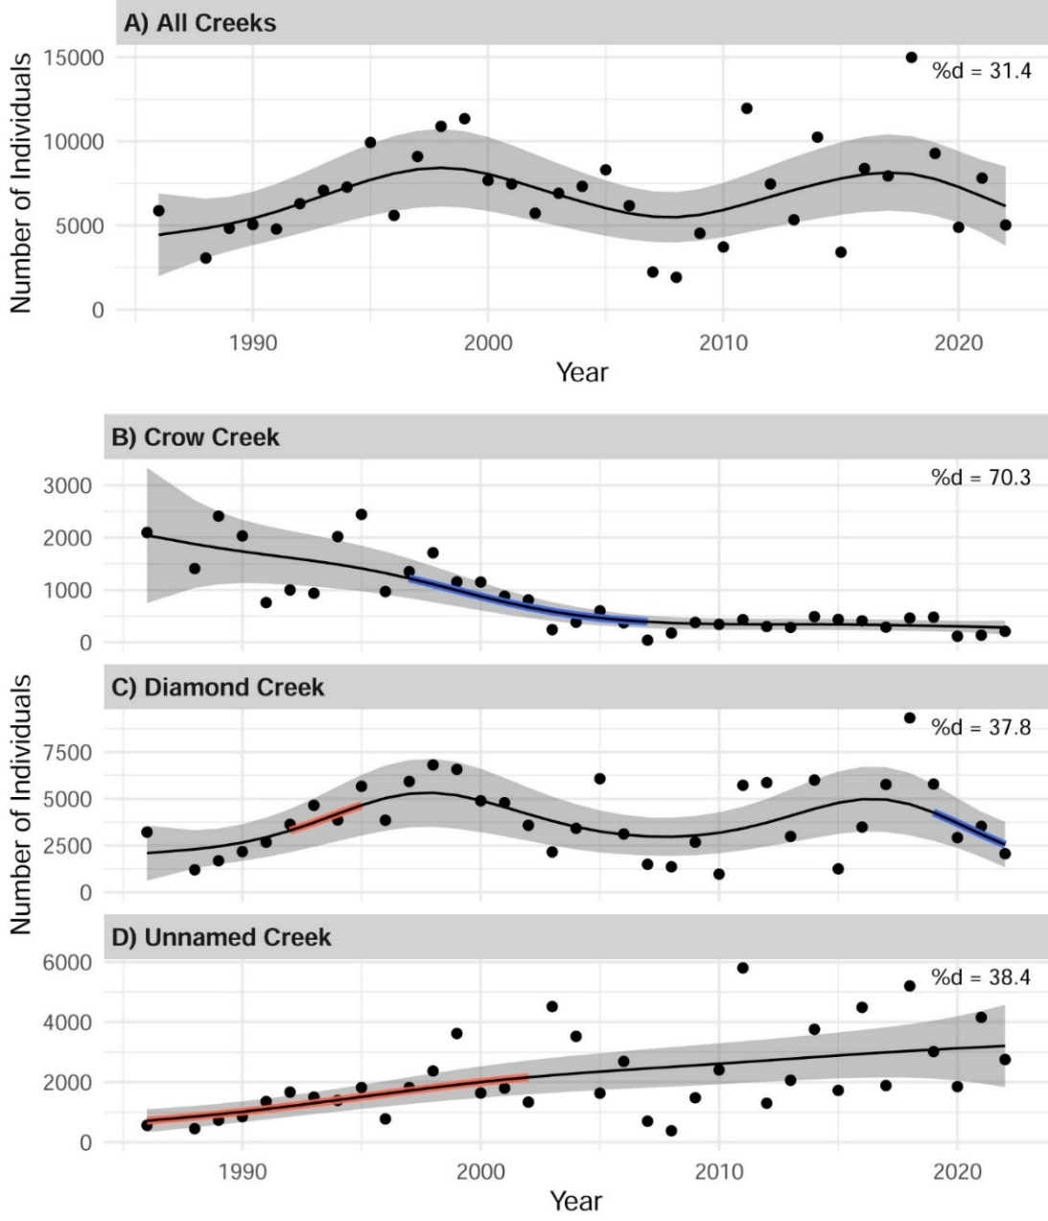

Figure 6. (A) Changes in the total population size of flowering Colorado butterfly plant (*Oenothera coloradensis*) individuals at F. E. Warren Air Force Base, Cheyenne, Wyoming, 1988-2023; (B)-(D) Changes in numbers on each of the three creek subpopulations. In all panels, points indicate census counts and black lines show curvilinear trends (black line) generated with GAMs. Red lines show periods of significant increase in number of flowering individuals, while blue lines show periods of significant decrease in number of flowering individuals. There were significant periods of decrease on Crow Creek 1999-2005) and Diamond Creek (2019-2023), and significant periods of increase on Unnamed Creek (1986-2001) and Diamond Creek (1992-1995). Percent deviance explained (% *d*) is a measure of effect size similar to *r*2 for linear models.

Of the four periods with significant changes to trends on the three creeks, only the positive changes on Diamond and Unnamed Creek were synchronous and similarly positive. These positive trend changes exceeded the negative trend changes in early years of COBP census on Crow Creek and in recent years of COBP census on Diamond Creek.

We used a model comparison algorithm for population time-series to identify all possible breakpoints and determine their significance. We detected three major trend breakpoints on two of the three creeks, none of which occurred synchronously, as one breakpoint in the total population (Figure 7). These breakpoints did not appear until at least five years after the start of such trends or much longer. They aligned with but did not mirror the periods of change shown in GAMs.

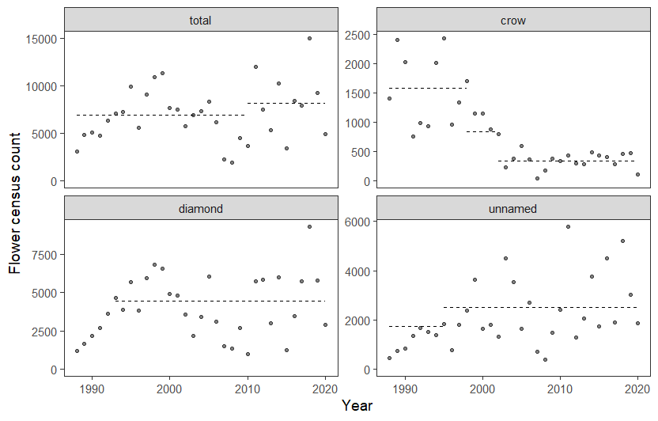 Figure 7: Breakpoints in the total population size of flowering Colorado butterfly plant (*Oenothera coloradensis*) individuals at F. E. Warren Air Force Base, Cheyenne, Wyoming, 1988-2023; and three creek subpopulations. Breakpoints were estimated for the monitoring time-series, and the modeled carrying capacity for each distinct era is plotted as dashed lines. If lines are missing, the algorithm gave unrealistic results that we exclude here. Data points are flower counts observed during monitoring.

It is noteworthy that significant trends were not detected until 5 or more years after the initation of monitoring, which potentially raises question whether five years is adequate to determine population trends in the PDM process.

## Base-wide trends

By three metrics, the total COBP population on WAFB is more stable than in any of its three subpopulations. The smoothest trendlines are evident in comparing WAFB trends with those on the three creek subpopulations (Figure 6). The population as a whole shows relative stability and was the only dataset to exhibit a breakpoint marking increase in the second half of the 36-year monitoring (Figure 7). The growth rates of the Base-wide population are the most “stable ” across time (no more than n-1 degrees of freedom in standard deviation) in comparison with the three creek subpopulation (Figure 8). The growth rate data and the documented breakpoint indicating increase in total numbers (Figure 7) are evidence that the whole population is more resilient than subpopulation components.

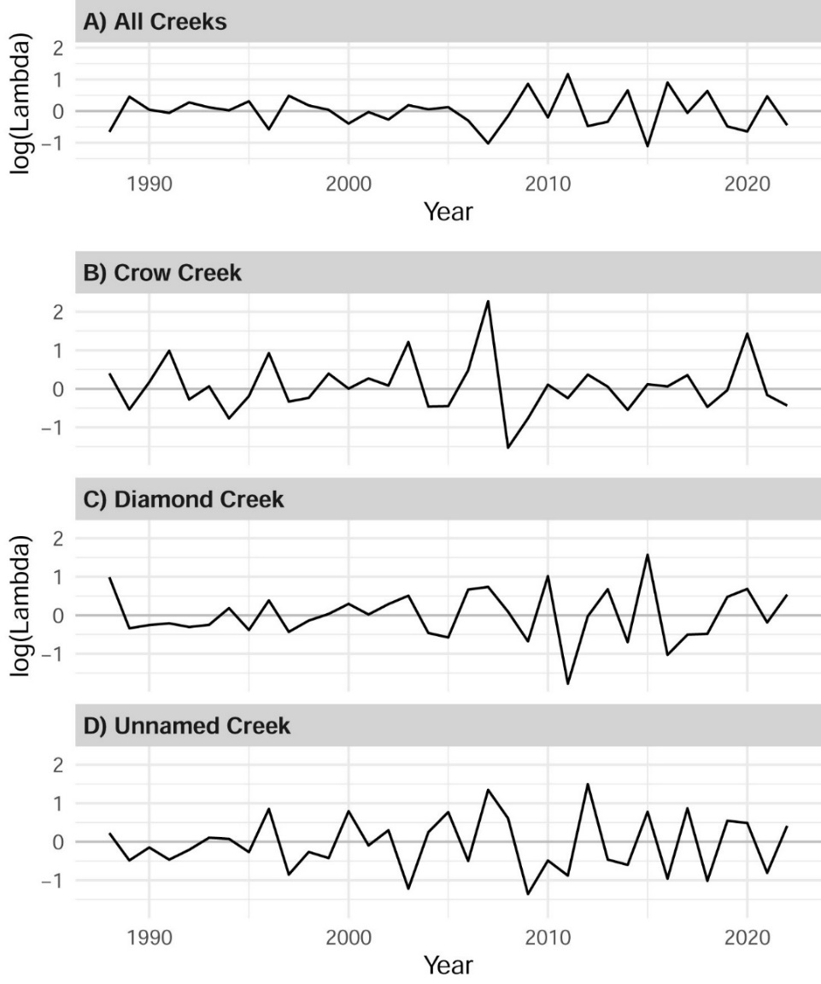

Figure 8. Growth rate (log(lambda)) of Colorado butterfly plant (*Oenothera coloradensis*) overall population and creek-level subpopulations at F. E. Warren Air Force Base (1988-2023). A log(Lambda) value of zero indicates a stable population or subpopulation, while positive and negative values indicate growing and shrinking populations, respectively.

The most surprising result of 2023 *O. coloradensis* monitoring was discovery of Ute ladies’-tresses (*Spiranthes diluvialis*) in overlapping habitat (below). Its occupied habitat is magnitudes smaller than COBP and warrants a monitoring framework tailored for this species.

## Ute ladies’-tresses documentation

Ute ladies’-tresses (ULT; *Spiranthes diluvialis*) was discovered for the first time on WAFB by Dorothy Tuthill on 9 Aug 2023 as part of this project. ULT occupies a small part of COBP habitat on Diamond Creek, a swale set back from the creek. A voucher specimen was collected for documentation (Heidel and Tuthill xx RM), a population count was made, a GPS point was taken, its habitat was described, and photographs of the habitat and setting were taken. A record of the discovery is presented in Appendix D. The swale has been deliberately visited for COBP monitoring purposes since at least since 2002. COBP individuals have been found over time at edges of the swale and occasionally within it. They usually grow over twice as tall as ULT, making it less likely that ULT would be detected than COBP. More important, ULT has a narrower phenology window than COBP. The latter starts flowering in late July and can continue non-stop until the first frost, given sufficient soil moisture. However, ULT may only be in flower for two weeks in some years, and it can shift in timing between years depending on the growing season. It is possible that the wet 2023 growing season was conducive to some aspect of its flowering that made it more conspicuous or shifted its timing to more closely overlap with that of COBP.

ULT is a long-lived perennial that can flower many times in its life cycle, unlike COBP. It also has “seasonal dormancy” that allows it to survive belowground for an entire growing season, escaping detection. Its vegetative growth form is even more difficult to detect than the ground-hugging basal rosettes of COBP. It is recommended that ULT’s occupied habitat be divided into lanes for exhaustive monitoring of flowering individuals, and that irregularities in the swale boundary be mapped using GPS waypoints. It is further recommended that tallies record both discrete clumps, and total number of stems. This can be addressed in a baseline ULT monitoring report as part of 2024 WAFB fieldwork.

# DISCUSSION

The WAFB population of COBP is among the largest, most extensive known COBP population, and has multiple, hydrologically diverse habitats. The 1988-2023 dataset demonstrates its resiliency to a drought event (1999-2008) and the normalcy of oscillating numbers between years.

It is also the only population that exists in relatively stable environmental conditions, without the disturbance of agricultural practices. Even though habitats are not used as hayland or rangeland, they are used by wildlife and subject to all the vagaries of High Plains climate with occasional, usually limited levels of flooding and insect herbivory. However, this does not mean that the vegetation has been static over time. Crow Creek habitat saw woody encroachment, and both Diamond and Unnamed Creek have seen increased cover of native species in much of occupied habitat. Weed cover has also varied greatly, expanding on all three creeks, and in some cases, declining with control efforts. We hypothesize that overall trends on the Base and its creeks are correlated with hydrologic conditions. COBP data from WAFB indicates that it is not a “disturbance-requiring species” (FWS 2017) but rather a resilient species of the plains adapted to the intrinsically dynamic conditions within and between years.

Despite the relatively unchanging conditions, it exhibits marked oscillation. Separate demographic analysis has emphasized the importance of negative density dependence for maintaining stable growth rates for *O. coloradensis* (Stears 2022, Stears et al. In preparation). Negative density-dependence is the tendency of a population to increase in size following years of low abundance, a strategy that many rare species employ to avoid extinction (Rabinowitz 1981). The growth rates of subpopulation segments on the three tend to follow a cyclical trend (Figures 4-5), with numbers declining in the years following high abundance, and numbers increasing in the years following low abundance. These fine-scale temporal trends have been observed in all subpopulations across the census period and are even more evident in the data from individual polygons, regardless of the overall trend in subpopulation size in a given creek drainage.

Recent demographic analysis also indicates the importance of a seedbank stage for maintaining positive population growth rates of this species, allowing it to persist in the long term (Stears 2022). Seeds can persist in the soil for several years before germination, and can thus serve as a buffer against extirpation at the micro-site scale following years with unfavorable conditions for flowering or seed production. A comparison of COBP on WAFB with other populations (Crystal Strouse pers. comm., Julie Reeves pers. comm.) indicates that interannual fluctuations in flowering plant numbers at other monitored populations are even more extensive than the variation observed at WAFB. This cyclical nature of COBP abundance is highly relevant to monitoring and conservation efforts, as it indicates that short intervals of monitoring will not always capture longer-term increases or declines.

The WAFB population has been treated as a single dataset in running the Mann-Kendall tests used in PDM metrics. We recommend running the Mann-Kendall tests used in PDM metrics for the separate creek subpopulations, and for random and deliberately-selected time intervals of five or more years by creek, as relevant to understanding PDM outputs for smaller populations and settings that are more uniform in habitat (or management).

Three lines of data analysis are presented in this report that indicate the population as a whole is more stable than any creek subpopulation. This is consistent with a demographic strategy for long-term population persistence, “asynchrony among population segments,” which has been documented in other rare species (Dibner, 2019). This strategy relies on spatial environmental heterogeneity between subpopulations, which leads to divergent degrees of environmental stress on individuals in different subpopulations, and in-turn, different population growth rates in these subpopulations. However, at the population level, it is possible to maintain a positive population growth rate if growth in some subpopulations adequately compensates for decline in others. This phenomenon is very consistent with our observations at WAFB, and leads us to conclude that the 3-creek system on WAFB provides redundancy within the population, and has the potential to confer resilience to local disturbance or environmental stochasticity. his conclusion is tempered by the fact that COBP re in decline on the creek with greatest stream reach of occupied habitat (Crow Creek), and that the creek with the highest numbers has had a recent significant decline (negative breakpoint on Diamond Creek), and that the creek with the least extent of occupied habitat (Unnamed Creek) has had an outsized role in recent positive trends. It remains to be seen whether this subpopulation structure will confer enough resilience for the population to withstand potential adverse impacts from global change.

All change is local and this is evident in examining the data at even finer scales. Crow Creek had a consistent pattern of COBP subpopulation decline. The exception is in one area that is the most isolated from influence of streamflow, but has groundwater movement from the slope above. However, not all influences are local. The COBP subpopulation on Crow Creek is possibly influenced by water management practices outside the Base and certainly by catchment conditions.

Diamond Creek has perhaps the most extensive occupied COBP habitat, and most intact hydrological gradients in broad riparian corridors. While its COBP numbers exhibited net increase, there have been multiyear swings in numbers that are not mirrored on the other creeks. It, too, is potentially influenced by water management immediately outside the Base.

Unnamed Creek showed the steadiest COBP subpopulation growth despite wide variation in census counts from year to year. Unnamed Creek subpopulation sizes approach those of Diamond Creek, yet the area of occupied habitat in this drainage is far smaller than the other two. The high density and concentrated distribution of this subpopulation place a premium on maintaining habitat conditions suitable for COBP on Unnamed Creek. The upper end of the creek drainage was trenched in 2022 below road construction. This had the apparent effect of moving greater water volumes into occupied habitat that persisted at deeper levels than past years. The habitat and COBP trend consequences are unknown.

What do our results mean for COBP on WAFB? They place a premium on maintaining local hydrological conditions, including upkeep of culverts, ditch contours and runoff systems. The management of beaver dams might be considered further. They also place a premium on management of riparian woodland, shrubland and weed cover, since increasing cover has a potentially negative effect on COBP numbers as evidenced by the declines on Crow Creek, where substantial shrub encroachment has occurred. Beyond Base boundaries, the Crow Creek subpopulation, if not also the Diamond Creek subpopulation, might be as significantly affected by hydrological conditions in the watershed above WAFB as inside WAFB.

It is beyond the scope of this study to project population trends. However, population scenarios using Population Viability Analysis (PVA) modeling have been prepared to simulate prolonged population and subpopulation trends associated with weather intervals from monitoring years for extended periods into the future. These simulations support population resilience through 2040 (Wepprich 2021), but do not factor in climate change. A revised PVA that addresses climate change might be relevant to the Post-Delisting Monitoring process.

## 2024 Monitoring plans

COBP monitoring work on WAFB will start in early August 2024. Flea beetle herbivory and midsummer mortality will be checked in advance if hot, dry conditions prevail. We support research communication, coordination and collaboration with others in Colorado and Wyoming who are monitoring and managing COBP.

# ACKNOWLEDGEMENTS

Monitoring and analysis of COBP trends continued in 2023 under a cooperative agreement between the U.S. Fish and Wildlife Service and Wyoming Natural Diversity Database with the coordination of Alex Schubert and Pamela Sponholtz, and the support of the F. E. Warren Air Force Base (WAFB; U.S. Air Force, Department of Defense). Coordination in prior years was provided by Tim Grosch, John McKinley, Jennifer Howenstine, Lori Ford, Cathryn Pesenti, Tom Smith, Walt Lenz and Bill Metz in the Environmental Element, Francis E. Warren Air Force Base.

Annual census monitoring of COBPon WAFB was planned and conducted by Wyoming Natural Diversity Database (WYNDD) as initiated by Hollis Marriott (1986-1992), pursued by Walter Fertig (1993-2000), and continued by Heidel with critical help of many other botanists through the years. Hollis Marriott kindly provided her perspectives and insights during a revisit to the Base in 2014.

Annual COBP census data on WAFB was analyzed using Pearson’s correlation coefficient and Spearman’s rank coefficients with climate variables was first performed in 2003 by Scott Laursen (WYNDD) followed by repeat testing of Pearson’s correlation coefficients and added multiple regressions in 2004 and 2005 by Laura Hudson (WYNDD). Generalized Additive Model analysis and supporting summary statistics were developed by Zach Wallace (WYNDD) in 2019-2021. Tyson Wepprich provided the break-point analysis of census trends (Wepprich 2021).

Annual COBP demographic data on WAFB was analyzed using population viability analysis (PVA) in a master thesis by Sandra Floyd (Colorado State University) in 1992-1994 (Floyd 1995, Floyd and Rank 1998). Census data collected in this study has also been used for PVA starting in 2007 and most recently in 2021 by Tyson Wepprich (Oregon State University), updated in tandem with this study by Alice Stears (University of Wyoming). New demographic data was collected and PVA work on it was conducted in Daniel Laughlin’s lab by Alice Stears. Laughlin also prepared Figure 3.

This monitoring project benefited from the pilot monitoring of COBP that was conducted by Robert Dorn and Robert Lichvar (Mountain West Environmental Services), and the management response research of Linda Munk, Leah Burgess and Ann Hild (University of Wyoming).

Earlier reports benefited from reviews by Alex Schubert (FWS), Julie Reeves (FWS), Tim Grosch (FWS), John McKinley (WAFB), Jennifer Howenstine (WAFB), Lori Ford (WAFB), Cathryn Pesenti (WAFB), Gary Beauvais (WYNDD), and Ken Gerow (University of Wyoming). The discussions, information exchanges and consultations with all researchers working on COBP are gratefully acknowledged.

# LITERATURE CITED

Bahlai, C. A., and E. F. Zipkin. 2020. The Dynamic Shift Detector: An algorithm to identify changes in parameter values governing populations. PLOS Computational Biology 16:e1007542.

Brown, G. 1999. Exploratory molecular characterization of *Gaura neomexicana* ssp. *coloradensis* - variability in the F. E. Warren Air Force Base populations. Report prepared for F. E. Warren Air Force Base by the Dept. of Botany, University of Wyoming, Laramie, WY.

Brown, G. 2000. Inter-simple Sequence Repeat (ISSR) variation in three populations of *Gaura neomexicana* ssp*. coloradensis*, F. E. Warren Air Force Base, Cheyenne, Wyoming. Report prepared for F. E. Warren Air Force Base by the Dept. of Botany, University of Wyoming, Laramie.

Curtis, C.J. and G.L. Simpson. 2014. Trends in bulk deposition of acidity in the UK, 1988–2007, assessed using additive models. Ecological Indicators 37:274-286.

Dibner, R. R., M. L. DeMarche, A.M.Louthan, and D.F. Doak. 2019.Multiple mechanisms confer stability to isolated populations of a rare endemic plant. Ecological Monographs 89(2):e01360. 10.1002/ecm.1360

Fertig, W. 2000. Status review of the Colorado butterfly plant (*Gaura neomexicana* ssp.

*coloradensis*). Report prepared for the Wyoming Cooperative Fish and Wildlife Research Unit, US Fish and Wildlife Service, and Wyoming Game and Fish Department by the Wyoming Natural Diversity Database, Laramie.

Floyd, S. K. 1995. Population structure, dynamics, and genetics of *Gaura neomexicana* ssp.  *coloradensis* (Onagraceae), a rare semelparous perennial. Master Thesis, Dept. of

Environmental, Population, and Organismic Biology, University of Colorado, Boulder.

Floyd, S.K. and T. Ranker. 1998. Analysis of a transition matrix model for *Gaura neomexicana*  ssp. *coloradensis* (Onagraceae) reveals spatial and temporal demographic variability.

International Journal of Plant Sciences 159 (5): 853-863.

Gerber, L. and M. Gonzalez-Suarez. 2010. Population viability analysis: origins and contributions. Nature Education Knowledge 3(10): 15-18.

Heidel, B. 2007. 19-year population trends of a short-lived riparian species, Colorado butterfly plant (*Gaura neomexicana* ssp. *coloradensis*; Onagraceae) on F. E. Warren Air Force Base, Laramie County, Wyoming. Prepared for the U.S. Air Force by the Wyoming Natural Diversity Database, Laramie.

Heidel, B. and J. Handley. 2011. 23-year population trends of Colorado butterfly plant (*Gaura neomexicana* ssp. *coloradensis;* Onagraceae), a short-lived riparian species on F. E. Warren Air Force Base. Prepared for F. E. Warren Air Force Base by the Wyoming Natural Diversity Database (University of Wyoming), Laramie, WY.

Heidel, B., L. Tronstad and J. Handley. 2011. Flea beetle (*Altica* spp.) herbivory on a threatened plant, F. E. Warren Air Force Base, Wyoming. Natural Areas Journal 31: 283-287.

Heidel, B., J. Handley and D. Tuthill. 2019. 31-year population trends of Colorado butterfly plant (*Oenothera coloradensis*; Onagraceae), a short-lived riparian species on F. E. Warren Air Force Base. Prepared for U.S. Fish and Wildlife Service and F. E. Warren Air Force Base by the Wyoming Natural Diversity Database (University of Wyoming), Laramie, WY.

Heidel, B., D. Tuthill and Z. Wallace. 2020. 32-year population trends of Colorado butterfly plant (*Oenothera coloradensis*; Onagraceae), a short-lived riparian species on F. E. Warren Air Force Base. Prepared for U.S. Fish and Wildlife Service and F. E. Warren Air Force Base by the Wyoming Natural Diversity Database (University of Wyoming), Laramie, WY.

Heidel, B., D. Tuthill and Z. Wallace. 2021. 33-year population trends of Colorado butterfly plant (*Oenothera coloradensis*; Onagraceae), a short-lived riparian species on F. E. Warren Air Force Base. Prepared for U.S. Fish and Wildlife Service and F. E. Warren Air Force Base by the Wyoming Natural Diversity Database (University of Wyoming), Laramie, WY.

Heidel, B., D. Tuthill and Z. Wallace. 2022. 34-year population trends of Colorado butterfly plant (*Oenothera coloradensis*; Onagraceae), a short-lived riparian species on F. E. Warren Air Force Base. Prepared for U.S. Fish and Wildlife Service and F. E. Warren Air Force Base by the Wyoming Natural Diversity Database (University of Wyoming), Laramie, WY.

Heidel, B., D. Tuthill and A. Stears. 2023. 35-year population trends of Colorado butterfly plant (*Oenothera coloradensis*; Onagraceae), a short-lived riparian species on F. E. Warren Air Force Base. Prepared for U.S. Fish and Wildlife Service and F. E. Warren Air Force Base by the Wyoming Natural Diversity Database (University of Wyoming), Laramie, WY.

Marriott, H. 1988. Monitoring of Colorado butterfly plant (*Gaura neomexicana* ssp.

*coloradensis*) on F. E. Warren Air Force Base, 1984-1988. Report prepared for the US Air Force by the Wyoming Natural Diversity Database, Laramie.

R Core Team (2023). R: A language and environment for statistical computing. R

Foundation for Statistical Computing, Vienna, Austria. URL

<https://www.R-project.org/>.

Rabinowitz, D. 1981. Seven forms of rarity. Page *in* H. Synge, editor. The Biological aspects of rare plant conservation. John Wiley & Sons, Ltd.

Raven, P.H. and D.P. Gregory. 1972. A revision of the genus *Gaura* (Onagraceae). Memoirs Torrey Botanical Club 23:1-96.

Stears, A. E. 2022. Trait-based plant demographic response to environmental change. PhD Dissertation. Department of Botany, University of Wyoming, Laramie.

Stears, A. E., B. Heidel, M. Paniw, R. Slaguero-Gomez, D. C. Laughlin. In preparation. Population dynamics of a globally rare yet locally abundant endemic monocarpic perennial (*Oenoethera coloradensis*).

Stevenson, A. 1997. Soil survey of Laramie County, Wyoming – western half. United States Department of Agriculture, Natural Resource Conservation Service. U.S. Government Printing Office, Washington, D.C.

Tuthill, D.E. and G.K. Brown. 2003. Inter-simple sequence repeat (ISSR) variation in three populations of *Gaura neomexicana* ssp. *coloradensis* (Onagraceae), F. E. Warren Air Force Base, Cheyenne, Wyoming. Western North American Naturalist 63(2):251-257.

USDI Fish and Wildlife Service. 2000. Endangered and Threatened wildlife and plants:

Threatened status for the Colorado butterfly plant (*Gaura neomexicana* ssp. *coloradensis*) from southeastern Wyoming, northcentral Colorado, and extreme western Nebraska. Federal Register 65(202):62302-62310 by Mary Jennings. USDI Fish and Wildlife Service. 2010. Recovery outline for *Gaura neomexicana* ssp. *coloradensis* (Colorado Butterfly Plant). Posted electronically at: <http://ecos.fws.gove/tess_public/pub/listedPlants.jsp>.

USDI Fish and Wildlife Service. 2017. Species Biological Report for Colorado butterfly plant

(*Oenothera coloradensis*; formerly *Gaura neomexicana* subsp. *coloradensis*). U.S. Fish and Wildlife Service Ecological Service Cheyenne, Wyoming

U.S. Fish and Wildlife Service. 2019. Endangered and Threatened Wildlife and Plants; Removing *Oenothera coloradensis* (Colorado Butterfly Plant) From the Federal List of Endangered and Threatened Plants. 84, No. 214: 59570-59588.

USDI Geological Survey. 1989. National Water Summary 1988-1989 – Floods and Droughts: WYOMING, posted electronically by the U.S. Geological Survey at: <https://www.usgs.gov/centers/wy-mt-water/>.

USDI Geological Survey. 2018. Water resources site inventory for USGS stream gauge 06755960 on Crow Creek at 19th Street in Cheyenne, WY posted electronically by the U.S. Geological Survey at: [http://waterdata.usgs.gov/wy/nwis/inventory/?site_no=06755960.](http://waterdata.usgs.gov/wy/nwis/inventory/?site_no=06755960)

USDI National Oceanic and Atmospheric Administration – Western Regional Climate Center. 2023. Mean monthly temperature and precipitation data for Cheyenne, Wyoming. Posted electronically at: <https://wrcc.dri.edu/cgi-bin/cliMAIN.pl?wy1675> [Downloaded 2023].

Wepprich, T. 2021. Population models and forecasts using long-term monitoring data for a recently delisted riparian forb, *Oenothera coloradensis* (Colorado butterfly plant).

Wood, S.N. 2011. Fast stable restricted maximum likelihood and marginal likelihood estimation of semiparametric generalized linear models. Journal of the Royal Statistical Society (B) 73:3-36.

Wyoming Water Resources Data System & State Climate Office. 2024. Drought Monitor. Posted at: <https://www.wrds.uwyo.edu/drought/drought.html> .

1. 2023 is the 36th consecutive year of monitoring at WAFB beginning in 1988, though monitoring data was not collected at the scale of creek segments until 1989, a scale used for PVA analysis. The first year of data collecting was in 1988, making this the 36th year of data collecting.